**Notes: The comments will go by order of the yellow lines on each word that needs to be fixed.**

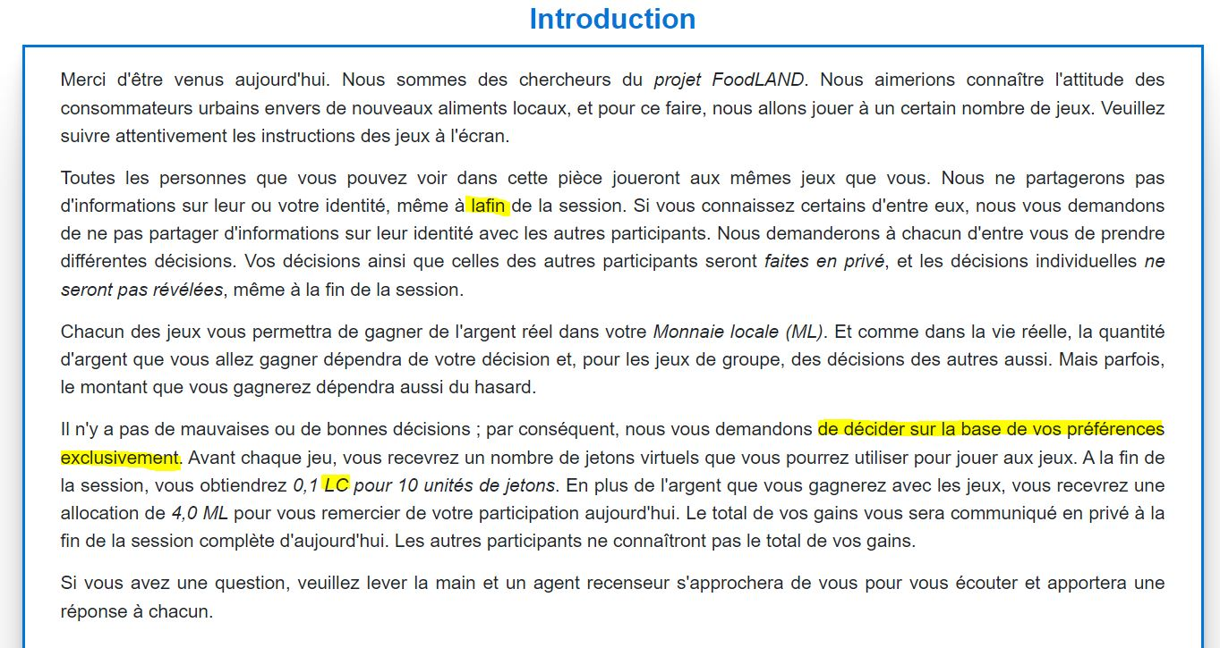

1. **La fin** (there needs to be space between both words).
2. **De décider exclusivement sur la base de vos préférences** (the last words of the sentence needs to come after the verb since it describe how that decision needs to be made).
3. **ML** (change LC with ML, to refer to Monnaie Locale -instead of Local Currency).

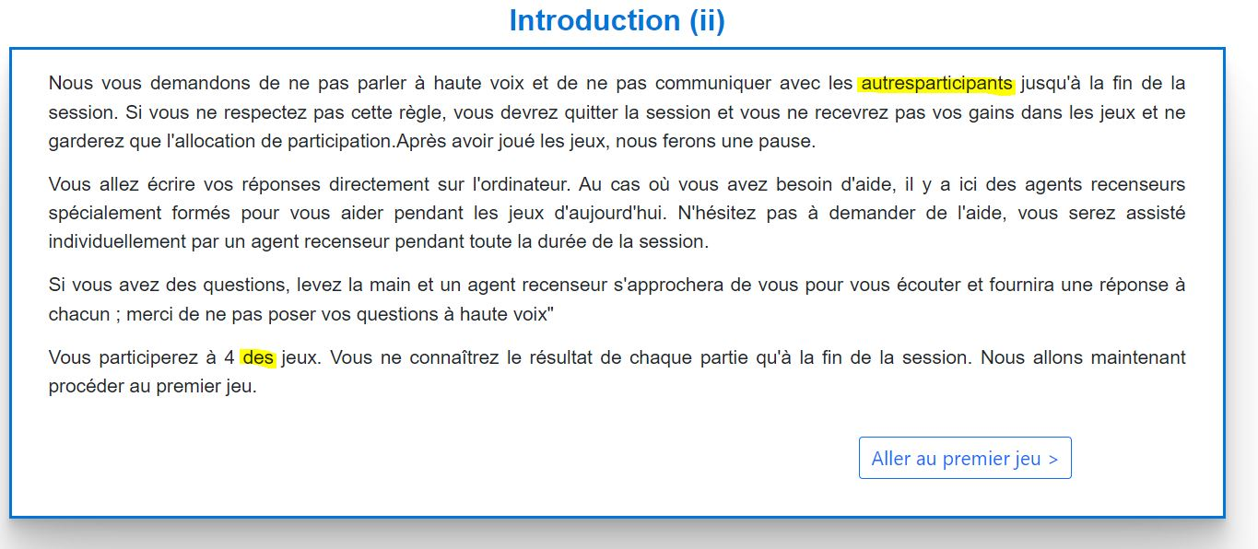

1. **autres participants** (there needs to be space between both words).
2. **à 4 jeux** (delete « des », there’s no need for it here).

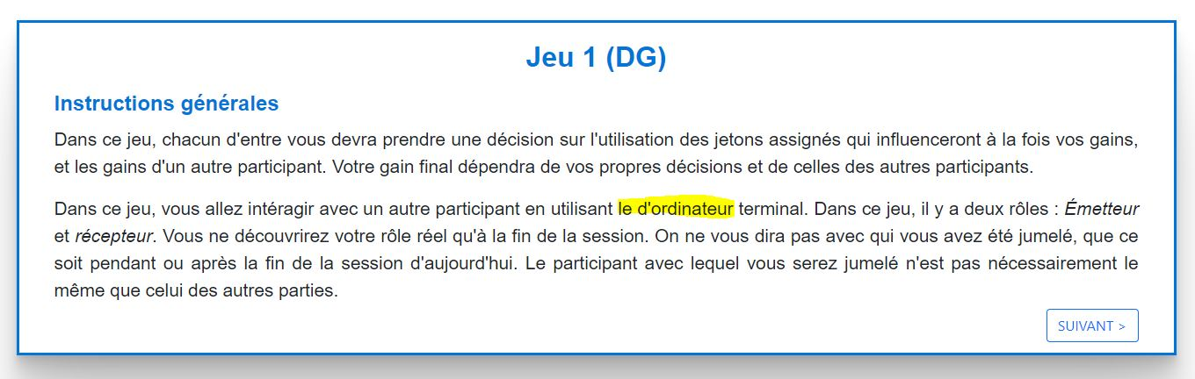

1. **l’ordinateur** (there are two articles at the same time, so one needs to be deleted).

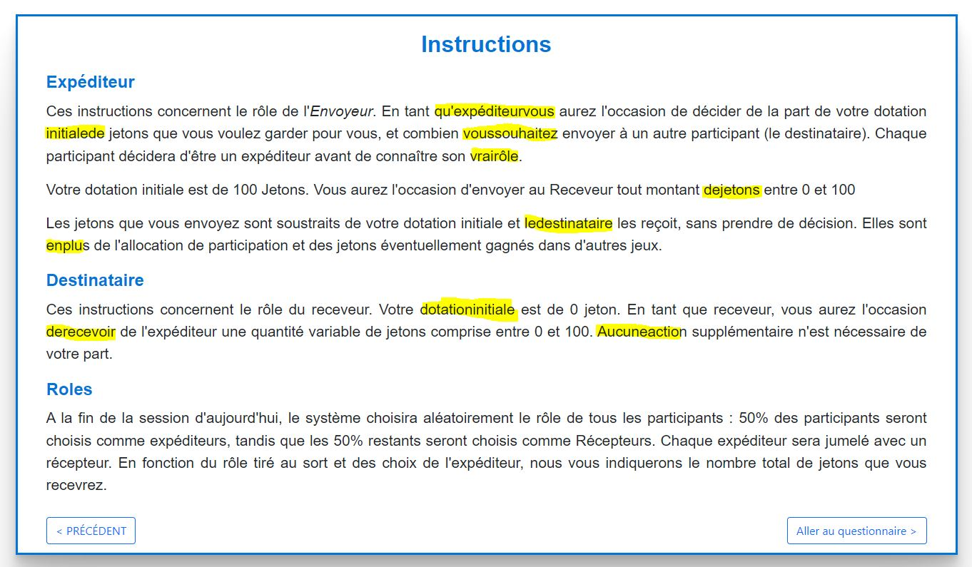

1. There needs to be space between all the words listed below:

* qu’expéditeur vous
* initiale de
* vous souhaitez
* vrai rôle
* de jetons
* le destinataire
* en plus
* dotation initiale
* de recevoir
* Aucune action.

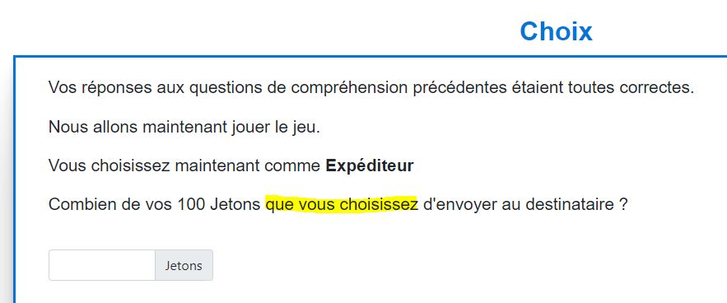

1. Combien de vos 100 jetons **choisissez-vous** d’envoyer au destinataire ? (It flows better when asking a question).

**Instructions – Local Farmers’ Association:**

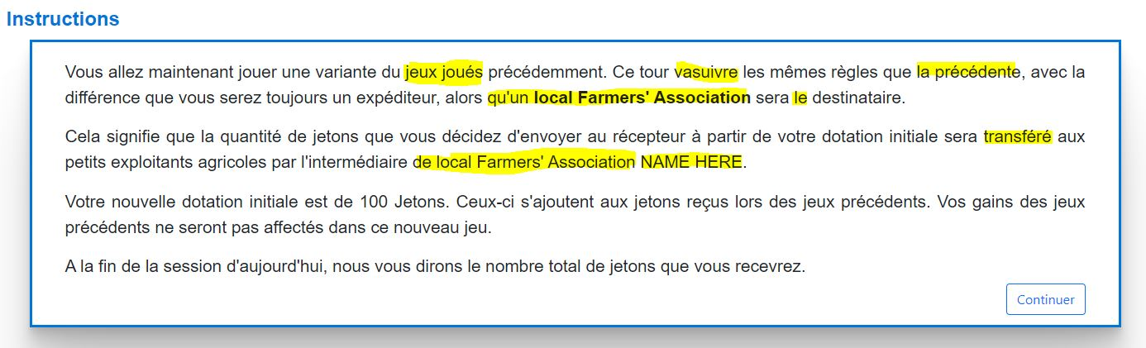

1. **du jeu joué** (Needs to be singular not plural).
2. **va suivre** (space between both words).
3. **le précédent** (refers to masculine word not feminine).
4. qu’une **association locale d’agriculteurs** (“Local Farmers’ Assocation" needs to be translated, and the article is linked with it before).
5. **la** destinatire (change the article, it refers to a feminine word not masculine).
6. **transférée** (add the e at the end, it refers to a feminine word).
7. l’intermédiaire d’une **association locale d’agriculteurs** (“Local Farmers’ Assocation" needs to be translated, and the article is linked with it before).
8. NAME HERE = **NOM ICI** (needs to be translated).

**Instructions – NGO:**

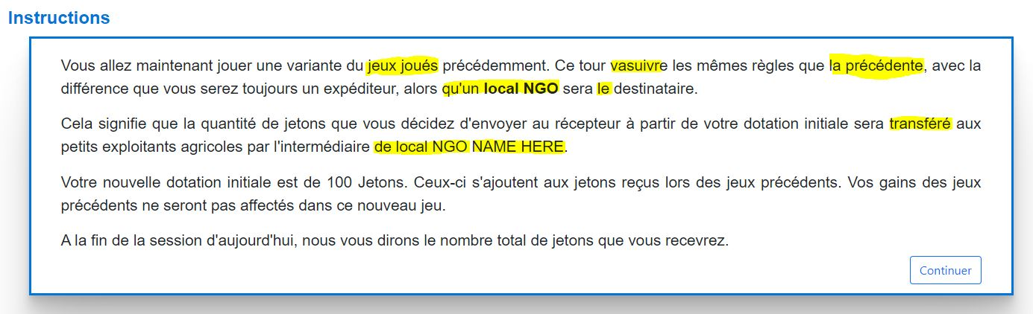

1. **du jeu joué** (Needs to be singular not plural).
2. **va suivre** (space between both words).
3. **le précédent** (refers to masculine word not feminine).
4. qu’une **ONG locale** (“Local NGO" needs to be translated, and the article is linked with it before).
5. **la** destinatire (change the article, it refers to a feminine word not masculine).
6. **transférée** (add the e at the end, it refers to a feminine word).
7. l’intermédiaire d’une **ONG locale** (“local NGO" needs to be translated, and the article is linked with it before).
8. NAME HERE = **NOM ICI** (needs to be translated).

**Description – Local Farmers’ Association:**

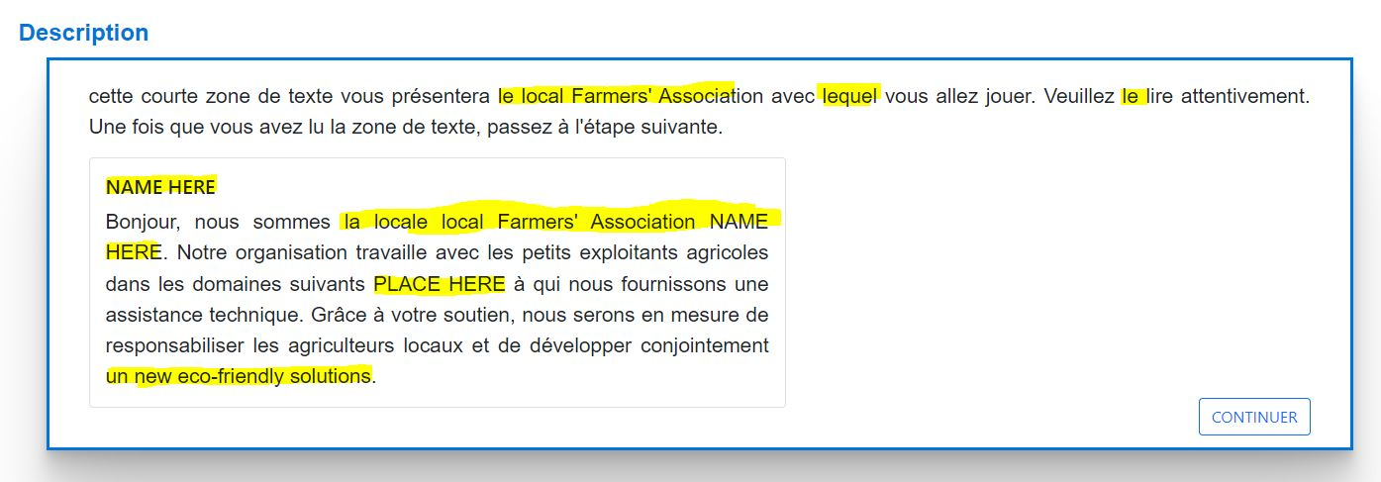

1. l’**association locale d’agriculteurs** (“Local Farmers’ Assocation" needs to be translated, and the article is linked with it before).
2. avec **laquelle** (refers to feminine word not masculine).
3. **la** (refers to feminine word not masculine).
4. NAME HERE = **NOM ICI** (needs to be translated).
5. l’**association locale d’agriculteurs** (“Local Farmers’ Assocation" needs to be translated, and the article is linked with it before).
6. PLACE HERE = **PLACER ICI** (needs to be translated).
7. un new eco-friendly solutions = **de** **nouvelles solutions écologiques** (needs to be translated, with the article).

**Description – NGO:**

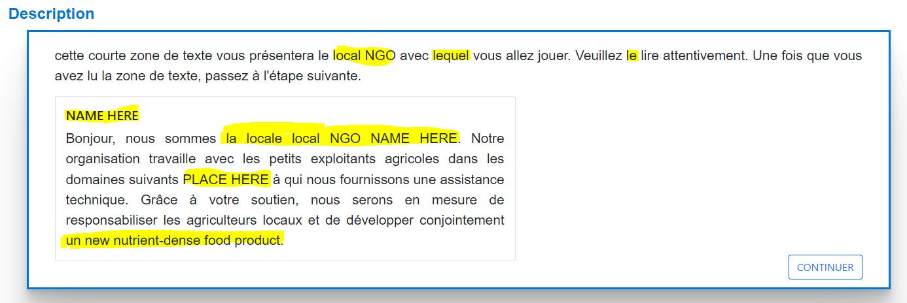

1. l’**ONG locale** (“Local NGO" needs to be translated, and the article is linked with it before).
2. avec **laquelle** (refers to feminine word not masculine).
3. **la** (refers to feminine word not masculine).
4. NAME HERE = **NOM ICI** (needs to be translated).
5. l’**ONG locale** (“Local NGO" needs to be translated, and the article is linked with it before).
6. PLACE HERE = **PLACER ICI** (needs to be translated).
7. un new eco-friendly solutions = **de** **nouvelles solutions écologiques** (needs to be translated, with the article).

**Choix – NGO:**

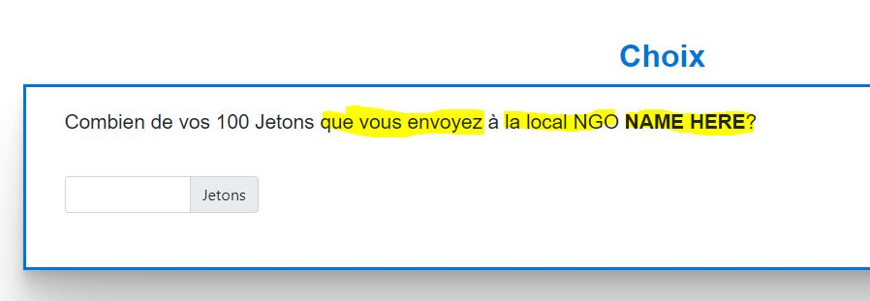

1. Combien de vos 100 jetons **envoyez-vous** à **l’ONG locale** **NOM ICI** ? (3 changes; translations and it flows better when asking a question).

**Choix - Local Farmers’ Association:**

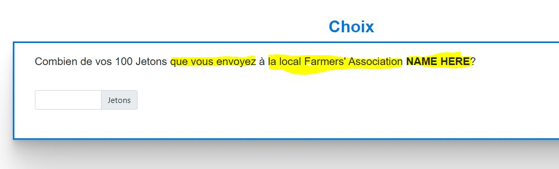

1. Combien de vos 100 jetons **envoyez-vous** à **l’association locale d’agriculteurs** **NOM ICI** ? (3 changes; translations and it flows better when asking a question).

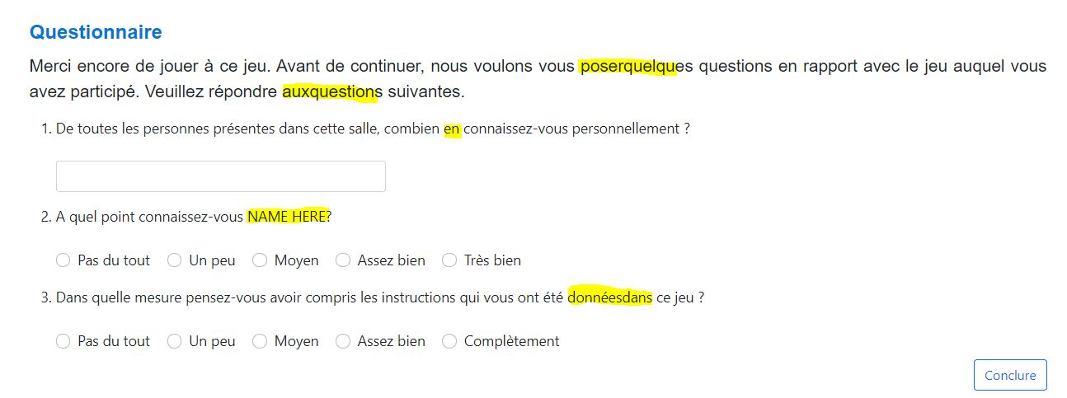

1. **poser quelques** (space between the two words).
2. **aux questions** (space between the two words).
3. ….., combine connaissez-vous personnellement ? (**delete « en »,** no need for it here).
4. NAME HERE = **NOM ICI** (translate it).
5. **données dans** (space between the two words).

**Jeu 2 (TG):**

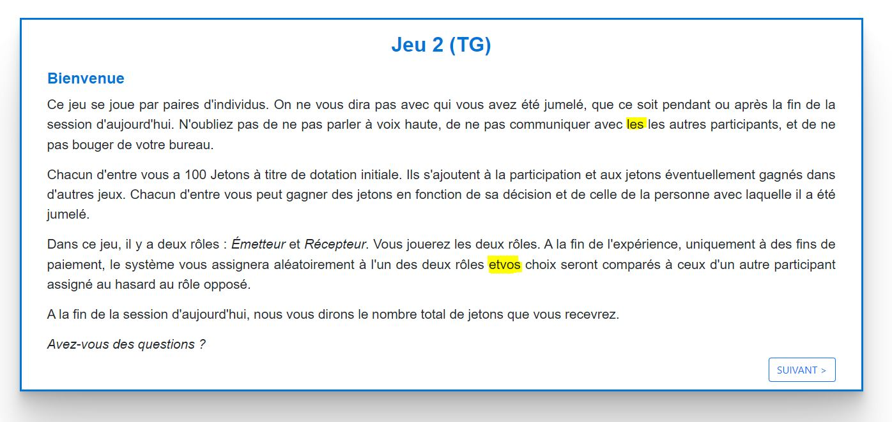

1. …., de ne pas communiquer avec les autres participants,…. (**delete one « les »,** there’s two).
2. **et vos** (space between the two words).

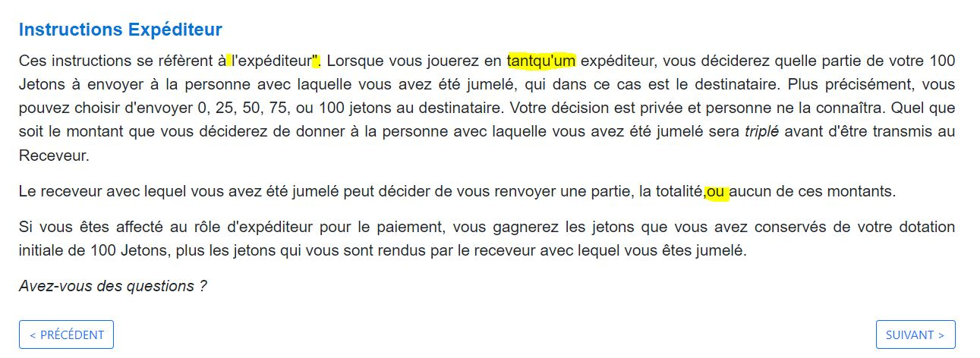

1. à l’**expéditeur** (delete the quotation marks " and **put the word in bold characters**).
2. **tant qu’un** (space between the two words, and there’s spelling mistake in the article).

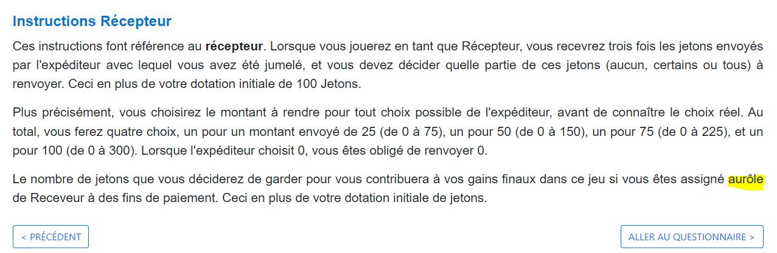

1. **au rôle** (space between the two words).

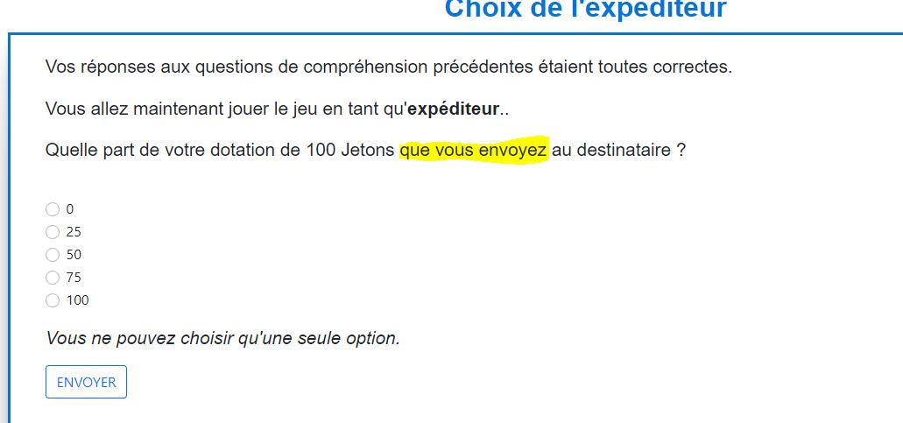

1. Quelle part de votre dotation de 100 jetons **envoyez-vous** au destinataire? (**Delete the yellow part and replace it with the one in bold.** It flows better when asking a question).

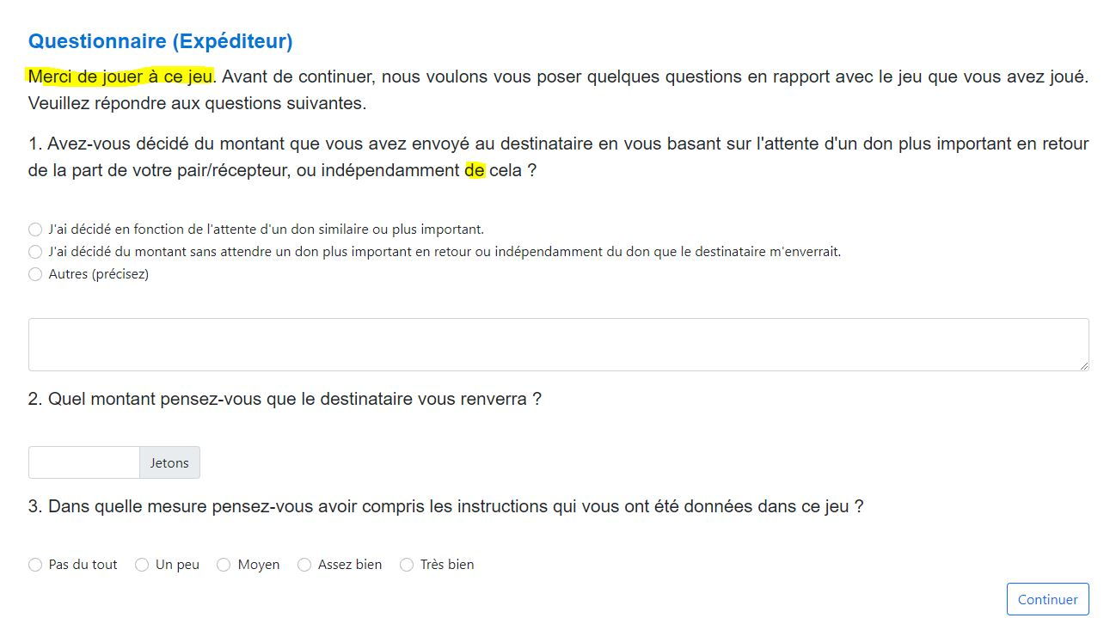

1. **Merci d’avoir jouer à ce jeu** (both are correct but the sentence needs to be in the past).
2. ou indépendamment **à** cela (the article « de » isn’t correct here).

**Questionnaire (Récepteur):**

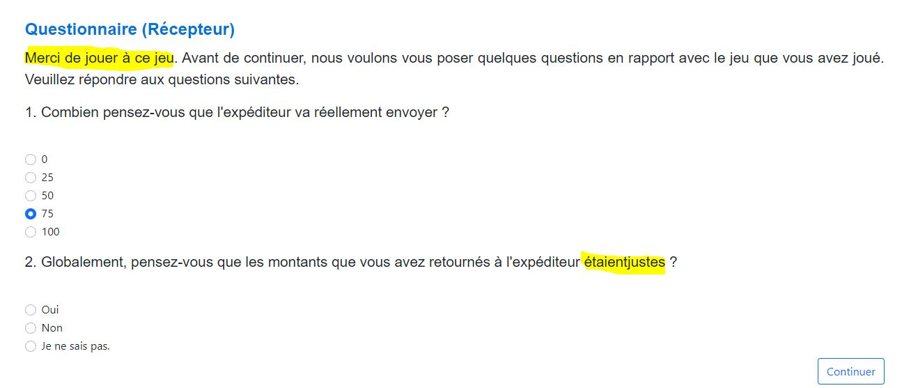

1. **Merci d’avoir jouer à ce jeu** (both are correct but the sentence needs to be in the past).
2. **étaient justes** (space between the two words).

**Instructions - NGO:**

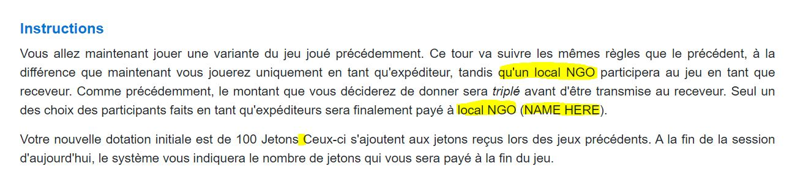

1. ….., tandis **qu’une** **ONG locale** (“local NGO” needs to be translated with the article before it).
2. ….. payé àl’**ONG locale** (“local NGO” needs to be translated with the article before it).
3. (**NAME HERE**) (Translate it).
4. 100 jetons**.** Ceux-ci…. (Add a point to separate both sentences).

**Instructions – local Farmers’ Association:**

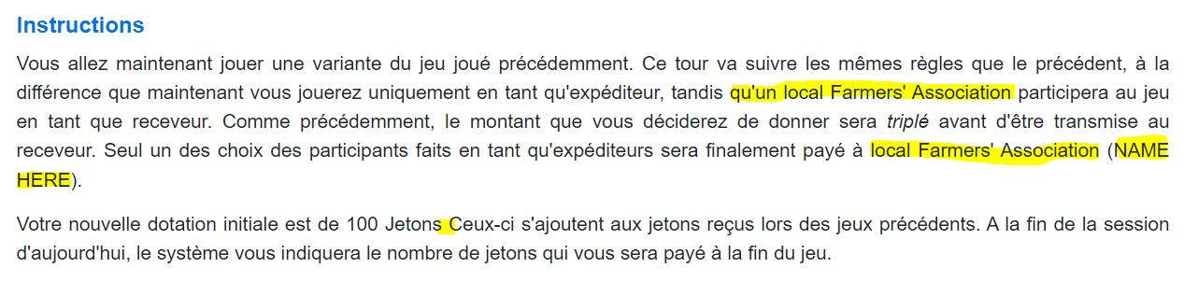

1. ….., tandis **qu’une** **association locale d’agriculteurs** (“local farmers’ association” needs to be translated with the article before it).
2. ….. payé àl’**association locale d’agriculteurs** (“local farmers’ association” needs to be translated with the article before it).
3. (**NAME HERE**) (Translate it).
4. 100 jetons**.** Ceux-ci…. (Add a point to separate both sentences).

**Description – NGO:**

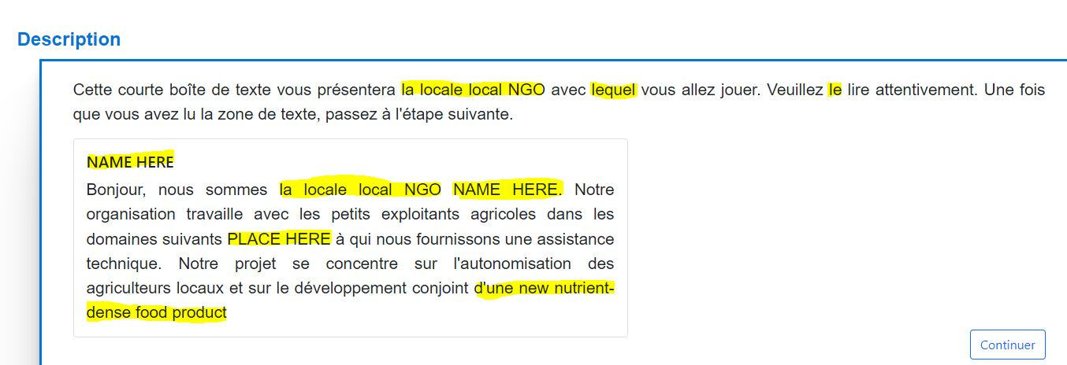

1. l’**ONG locale** (“Local NGO" needs to be translated, and the article is linked with it before).
2. avec **laquelle** (refers to feminine word not masculine).
3. **la** (refers to feminine word not masculine).
4. NAME HERE = **NOM ICI** (needs to be translated).
5. l’**ONG locale** (“Local NGO" needs to be translated, and the article is linked with it before).
6. PLACE HERE = **PLACER ICI** (needs to be translated).
7. a new nutrient-dense food product= **d’un nouveau produit alimentaire riche en nutriments** (needs to be translated, with the article).

**Description – Local Farmers’ Association:**

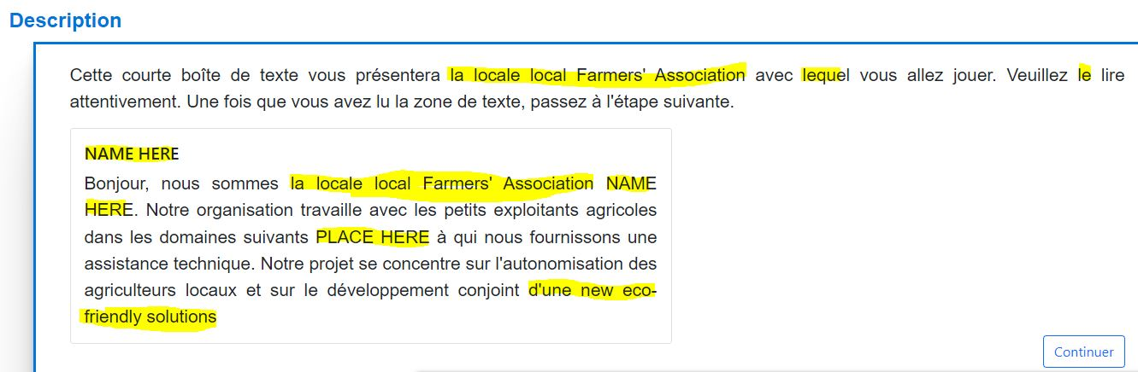

1. l’**association locale d’agriculteurs** (“Local Farmers’ Assocation" needs to be translated, and the article is linked with it before).
2. avec **laquelle** (refers to feminine word not masculine).
3. **la** (refers to feminine word not masculine).
4. NAME HERE = **NOM ICI** (needs to be translated).
5. l’**association locale d’agriculteurs** (“Local Farmers’ Assocation" needs to be translated, and the article is linked with it before).
6. PLACE HERE = **PLACER ICI** (needs to be translated).
7. a new nutrient-dense food product= **d’un nouveau produit alimentaire riche en nutriments** (needs to be translated, with the article).

**Choix - NGO:**

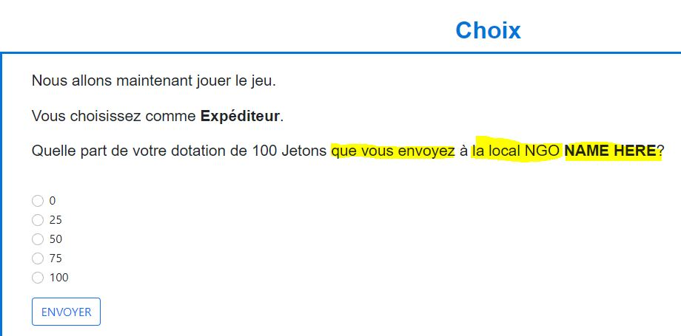

1. Quelle part de votre dotation de 100 jetons **envoyez-vous** à **l’ONG locale NOM ICI** ? (**Delete the yellow part and replace it with the one in bold.** 3 changes).

**Choix - Local Farmers’ Association:**

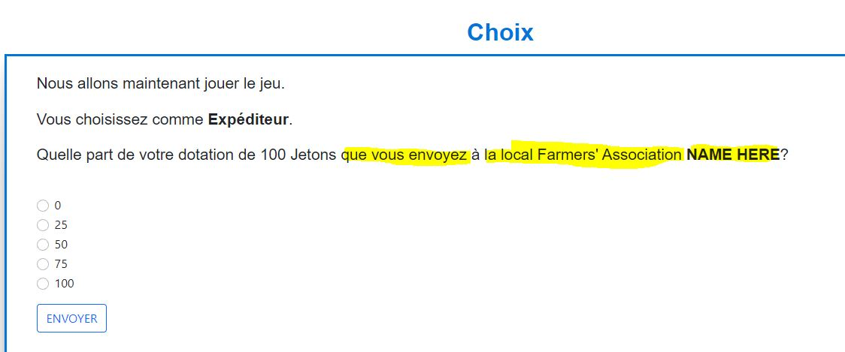

1. Quelle part de votre dotation de 100 jetons **envoyez-vous** à **l’association locale d’agriculteurs NOM ICI** ? (**Delete the yellow part and replace it with the one in bold.** 3 changes).

**Questionnaire Final - NGO:**

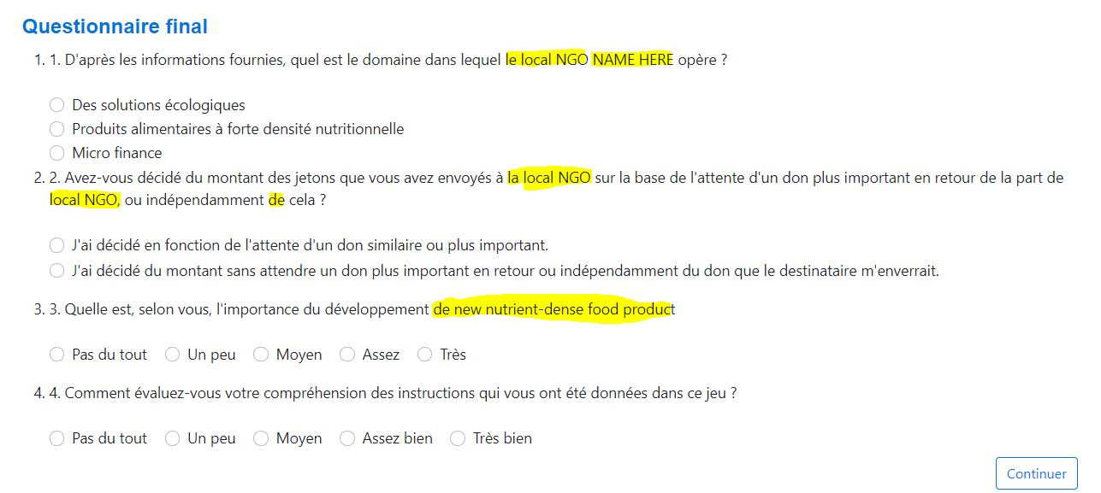

1. **l’ONG locale NOM ICI** (change the yellow part with this).
2. à **l’ONG locale**…….. de la part de **l’ONG locale**….(Change the yellow part with this).
3. ou indépendamment **à** cela (the article « de » isn’t correct here).
4. de new nutrient-dense food product= **d’un nouveau produit alimentaire riche en nutriments** (needs to be translated, with the article).

**Questionnaire Final - Local Farmers’ Association:**

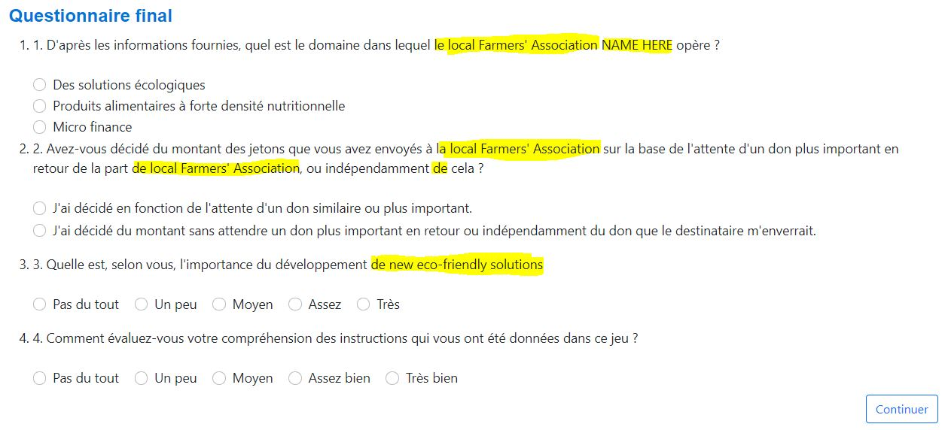

1. **l’association locale des agriculteurs NOM ICI** (change the yellow part with this).
2. à **l’association locale des agriculteurs**…….. de la part de **l’association locale des agriculteurs**….(Change the yellow part with this).
3. ou indépendamment **à** cela (the article « de » isn’t correct here).
4. de new eco-friendly solutions = **de nouvelles solutions écologiques** (needs to be translated, with the article).

**Jeu 3 (TP):**

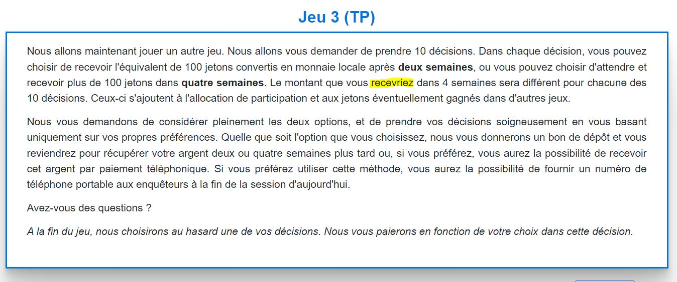

1. **recevrez** (wrong tense was used).

**Questionnaire:**

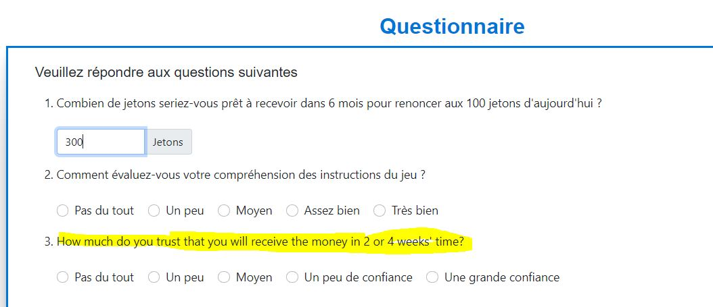

1. How much do you trust that you will receive the money in 2 or 4 weeks' time? **= Dans quelle mesure pensez-vous que vous recevrez l'argent dans 2 ou 4 semaines ?** (QT3 needs to be translated).

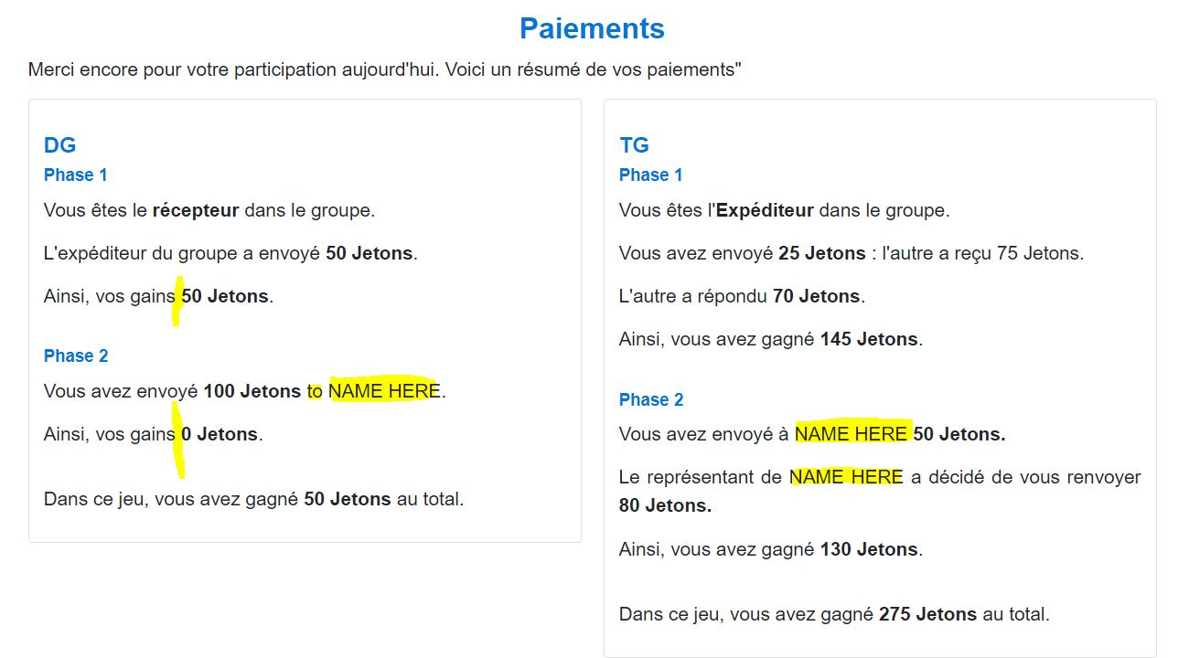

**Jeu 4 (RP):**

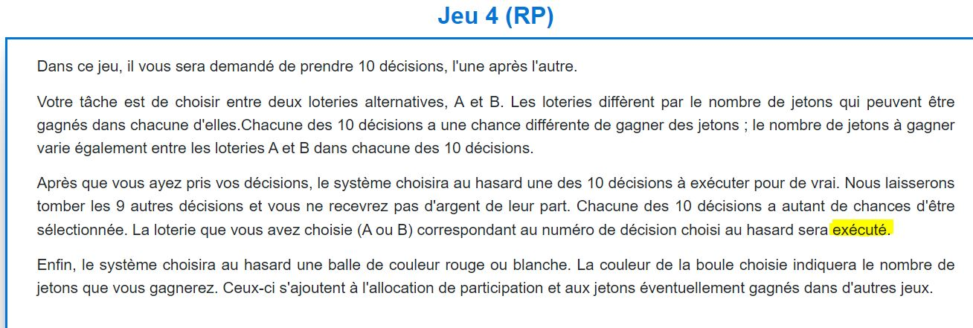

1. **exécutée** (Add an e at the end, it refers to a feminine word).

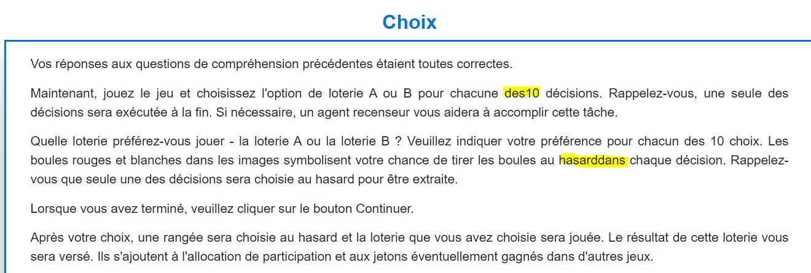

1. **des 10** (Space between the two words).
2. **hasard dans** (Space between the two words).



1. Ainsi, vos gains **sont** 50 Jetons (In Phase 1: a verb needs to be added or this sentence can be used like it has been in other parts “Ainsi, vous avez gagné 50 jetons”).
2. NAME HERE =**NOM ICI** (Needs to be translated).
3. Ainsi, vos gains **sont** 0 Jetons (In Phase 2: a verb needs to be added or this sentence can be used like it has been in other parts “Ainsi, vous avez gagné 0 jetons”).